 | 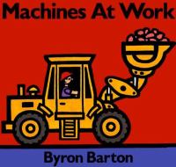 |  | Machines at Work  By Byron Barton  call number:  JJ/Barton  Look for more books by this author
 | 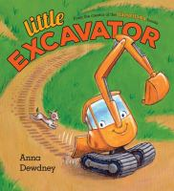 |  | Little Excavator  by Anna Dewdney  call number:  JJ/Dewdney
 | 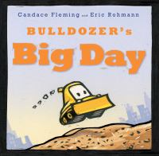 |  | Bulldozer’s Big Day  by Candace Fleming  call number:  JJ/Fleming  Look for more books by this author
 | 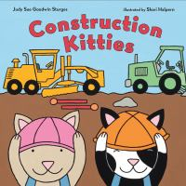 |  | Construction Kitties  by Judy Sue Goodwin-Sturges  call number:  JJ/Goodwin-Sturges
 | 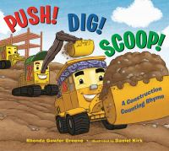 |  | Push! Dig! Scoop!  by Rhonda Gowler Greene  call number:  JJ/Greene
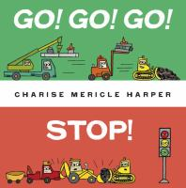 |  | Go! Go! Go! Stop!  by Charise Mericle Harper  call number:  JJ/Harper
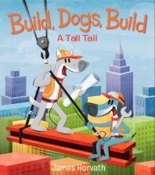 |  | Build, Dogs, Build  by James Horvath  call number:  JJ/Horvath
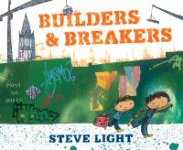 |  | Builders and Breakers  By Steve Light  call number:  JJ/Light
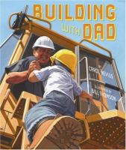 |  | Building with Dad  by Carol Nevius  call number:  JJ/Nevius
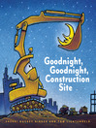 |  | Goodnight, Goodnight Construction Site  by Sherri Duskey Rinker  call number:  JJ/Rinker  Look for more books by this author
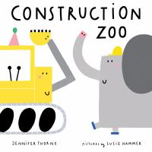 |  | Construction Zoo  by Jennifer Thorne  call number:  JJ/Thorne

For more books about construction vehicles, look for call numbers 621-629 in the Nonfiction and Early Reader Nonfiction sections.

