5th-6th Grade Reads
New, Upcoming, & Recommended for Fall 2017
Chelmsford Public Library

Genre Key

Adventure | AD | Humor | HU
Animals | AN | Mystery | MY
Fantasy | FA | Realistic | RE
Historical Fiction | HF | Sci-Fi | SF
Horror | HR | Sports | SP

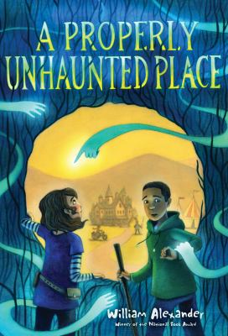 | A Properly Unhaunted Place  FA  by William Alexander  Y/Fic/Alexander  Rosa Ramona Díaz has just moved to the small, un-haunted town of Ingot—the only ghost-free town in the world. She doesn’t want to be there. She doesn’t understand how her mother—a librarian who specializes in ghost-appeasement—could possibly want to live in a place with no ghosts. Jasper Chevalier has always lived in Ingot. His father plays a knight at the local Renaissance Festival, and his mother plays the queen. Jasper has never seen a ghost. Then an apparition thunders into the festival grounds and turns the quiet town upside down.
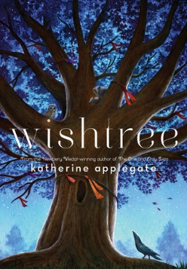 | Wishtree  AN  by Katherine Applegate  J/Fic/Applegate  "Trees can't tell jokes, but they can certainly tell stories." Red is an oak tree who is many rings old. Red is the neighborhood "wishtree"—people write their wishes on pieces of cloth and tie them to Red's branches. Along with her crow friend Bongo and other animals who seek refuge in Red's hollows, this "wishtree" watches over the neighborhood. You might say Red has seen it all. Until a new family moves in. Not everyone is welcoming, and Red's experiences are more important than ever
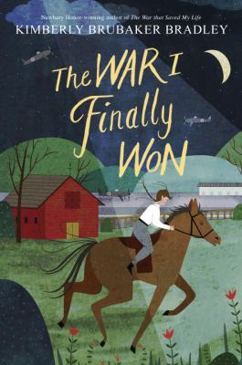 | The War I Finally Won (The War That Saved My Life #2)  HF  by Kimberly Brubaker Bradley  J/Fic/Bradley  World War II continues, and Ada and her brother, Jamie, are living with their loving legal guardian, Susan, in a borrowed cottage on the estate of the formidable Lady Thorton—along with Lady Thorton herself and her daughter, Maggie. Life in the crowded cottage is tense enough, and then Ruth, a Jewish girl from Germany, moves in. A German? The occupants of the house are horrified. But other impacts of the war become far more frightening. As death creeps closer to their door, life and morality during wartime grow more complex. Who is Ada now? How can she keep fighting? And who will she struggle to save?
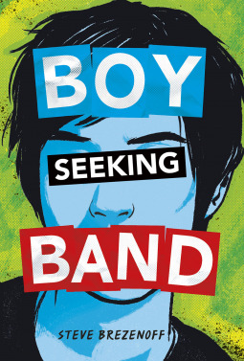 | Boy Seeking Band  RE  by Steven Brezenoff  Y/Fic/Brezenoff  Nell Perkins knows there is magic at work that she can’t yet understand. Her mother has been taken by witches and turned into a bird. Nell must journey to get her mother back, even if it takes her deep into the Wicked Places — the frightening realm where Nightmares resides. There she must break the spell and stop the witches from turning our world into a living nightmare.
Molly’s Story: A Dog’s Purpose Novel
AN

by Bruce W. Cameron
J/Fic/Cameron

Molly knows that her purpose is to take care of her girl, C.J., but it won't be easy. Neglected by her mother, Gloria, who won't allow her to have a dog, C.J. is going through some tough times. Molly's job is to stay hidden in C.J.'s room, cuddle up to her at night, and protect her from bad people. And no matter what Gloria does to separate them, nothing will keep Molly away from the girl that she loves.

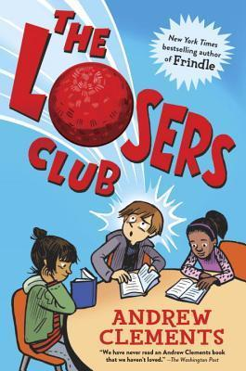 | The Losers Club  HU  By Andrew Clements  J/Fic/Clements  Sixth grader Alec can't put a good book down. So when Principal Vance lays down the law--pay attention in class, or else--Alec takes action. He can't lose all his reading time, so he starts a club. A club he intends to be the only member of. After all, reading isn't a team sport, and no one would want to join something called the Losers Club, right? But as more and more kids find their way to Alec's club--including his ex-friend turned bully and the girl Alec is maybe starting to like--Alec notices something. Real life might be messier than his favorite books, but it's just as interesting.
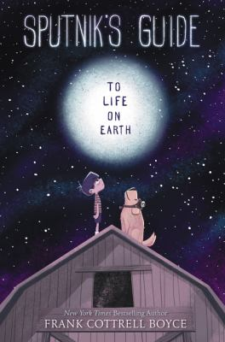 | Sputnik’s Guide to Life on Earth  SF  by Frank Boyce Cottrell  J/Fic/Cottrell  The Blythes are a big family who live on a small farm and sometimes foster children. Now Prez has come to live with them. But, though he seems cheerful and helpful, he never says a word. Then one day Prez answers the door to someone claiming to be his relative. As Prez dithers on the doorstep, Sputnik strolls right past him and introduces himself to everyone in the household. The family pat Sputnik on the head, call him a good boy and drop food into his mouth. It seems they all think Sputnik is a dog. It turns out that Sputnik is writing a guidebook to Earth called Ten Things Worth Doing on Earth, and he takes Prez on a journey to discover just those ten things. Each adventure seems to take Prez nearer to the heart of the family he is being fostered by. But they also take him closer to the day that he is due to leave them forever.
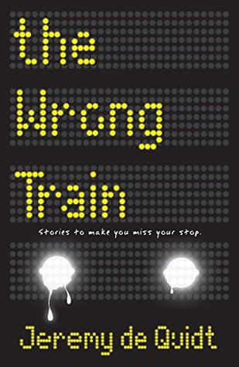 | The Wrong Train  HR  by Jeremy de Quidt  Y/Fic/de Quidt  Imagine you've just managed to catch your train and you realize it's the wrong one – you'd be annoyed of course, but not scared… yet. Imagine you get off the wrong train at the next station hoping to catch a train going back the way you came but the station is empty. Again you'd be annoyed, but not scared… yet. Imagine someone comes to the station, someone who starts to tell you stories to help you pass the time, but these aren't any old stories… Scared yet? You will be.
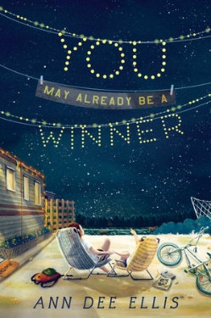 | You May Already Be a Winner  RE  by Ann Dee Ellis  J/Fic/Ellis  Twelve-year-old Olivia Hales has a foolproof plan for winning a million dollars so that she and her little sister, Berkeley, can leave behind Sunny Pines Trailer Park. Twelve-year-old Olivia Hales has a foolproof plan for winning a million dollars so that she and her little sister, Berkeley, can leave behind Sunny Pines Trailer Park.  But first she has to:  - Fix the swamp cooler and make dinner and put Berkeley to bed because her mom is too busy to do all that  - Write another letter to her dad even though he hasn't written back yet  - Become a super-secret spy to impress her new friend Bart  - Enter a minimum of fourteen sweepstakes a day. Who knows? She may already be a winner!
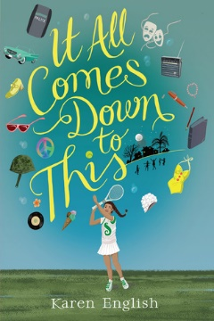 | It All Comes Down to This  HF  by Karen English  J/Fic/English  It’s 1965, Los Angeles. All twelve-year-old Sophie wants to do is write her book, star in the community play, and hang out with her friend Jennifer. But she’s the new black kid in a nearly all-white neighborhood; her beloved sister, Lily, is going away to college soon; and her parents’ marriage is rocky. There’s also her family’s new, disapproving housekeeper to deal with. When riots erupt in nearby Watts and a friend is unfairly arrested, Sophie learns that life—and her own place in it—is even more complicated than she’d once thought.  AD
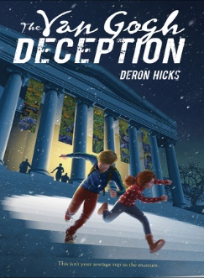 | The Van Gogh Deception  by Deron R. Hicks  Y/Fic/Hicks  When a young boy is discovered in Washington DC’s National Gallery without any recollection of who he is, so begins a high-stakes race to unravel the greatest mystery of all: his identity. As the stakes continue to rise, the boy must piece together the disjointed clues of his origins while using his limited knowledge to stop one of the greatest art frauds ever attempted.
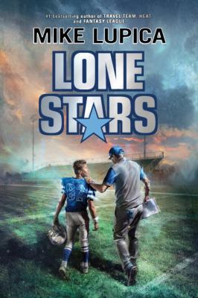 | Lone Stars  SP  by Mike Lupica  J/Fic/Lupica  When Coach Coop, a former star player for the Dallas Cowboys, starts exhibiting side effects from the many concussions he suffered while playing professionally, twelve-year-old wide receiver Clay Hollis becomes determined to help him get through the football season until Thanksgiving, when Coach plans to attend a ceremony honoring him and his former Super Bowl-winning teammates.
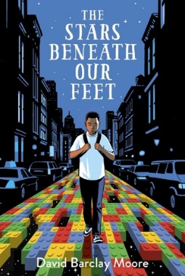 | The Stars Beneath Our Feet  RE  by David Barclay Moore  Y/Fic/Moore  It's Christmas Eve in Harlem, but twelve-year-old Lolly Rachpaul and his mom aren't celebrating. They're still reeling from his older brother's death in a gang-related shooting just a few months earlier. Then Lolly's mother's girlfriend brings him a gift that will change everything: two enormous bags filled with Legos. Lolly's always loved Legos, and he prides himself on following the kit instructions exactly. Now, faced with a pile of building blocks and no instructions, Lolly must find his own way forward.
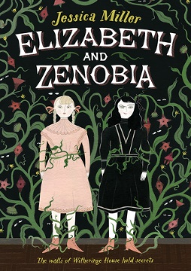 | Elizabeth and Zenobia  HR  by Jessica Miller  Y/Fic/Miller  When Elizabeth and her unusual and fearless friend Zenobia arrive at Witheringe House, peculiar things begin to happen. Especially in the forbidden East Wing. The flowers and vines of the wallpaper sometimes seem to be alive. A mirror has a surface like the water of a pond. And an old book tells a different story after midnight. Zenobia is thrilled by the strangeness, but Elizabeth is not so bold... Until she makes a mysterious and terrifying discovery.
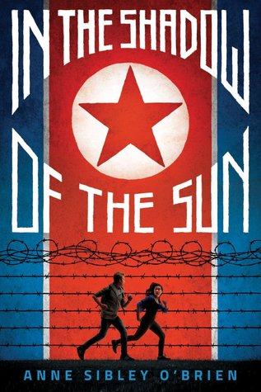 | In the Shadow of the Sun  AD  by Ann Sibley O’Brien  Y/Fic/O’Brien  North Korea is known as the most repressive country on Earth, with a dictatorial leader, a starving population, and harsh punishment for rebellion. Not the best place for a family vacation. Yet that's exactly where Mia Andrews finds herself, on a tour with her aid-worker father and fractious older brother, Simon. Mia was adopted from South Korea as a baby, and the trip raises tough questions about where she really belongs. Then her dad is arrested for spying, just as forbidden photographs of North Korean slave-labor camps fall into Mia's hands. The only way to save Dad: get the pictures out of the country. Thus Mia and Simon set off on a harrowing journey to the border, without food, money, or shelter, in a land where anyone who sees them might turn them in, and getting caught could mean prison -- or worse.
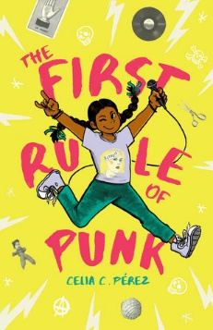 | The First Rule of Punk  RE  by Celia C. Pérez  J/Fic/Pérez  There are no shortcuts to surviving your first day at a new school—you can't fix it with duct tape like you would your Chuck Taylors. On Day One, twelve-year-old Malu (Maria Luisa, if you want to annoy her) inadvertently upsets Posada Middle School's queen bee, violates the school's dress code with her punk rock look, and disappoints her college-professor mom in the process. Her dad, who now lives a thousand miles away, says things will get better as long as she remembers the first rule of punk: be yourself. The real Malu loves rock music, skateboarding, zines, and Soyrizo (hold the cilantro, please). And when she assembles a group of like-minded misfits at school and starts a band, Malu finally begins to feel at home. She'll do anything to preserve this, which includes standing up to an anti-punk school administration to fight for her right to express herself!
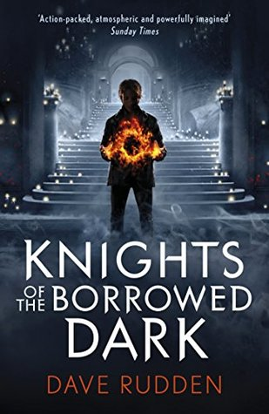 | Knights of the Borrowed Dark  FA  by Dave Rudden  J/Fic/Rudden  On a particularly dark night, the gates of Crosscaper Orphanage open to a car that almost growls with power. The car and the man in it retrieve Denizen Hardwick with the promise of introducing him to a long-lost aunt. But on the ride into the city, they are attacked. Denizen soon learns that monsters can grow out of the shadows. And there is an ancient order of knights who keep them at bay. Denizen has a unique connection to these knights, but everything they tell him feels like a half-truth. If Denizen joins the order, is he fulfilling his destiny, or turning his back on everything his family did to keep him alive?
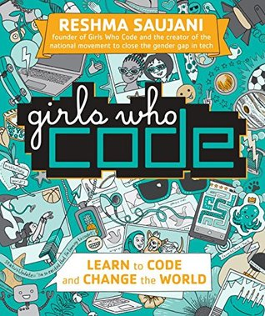 | Girls Who Code: Learn to Code and Change the World  by Reshma Saujani  005.1023/Sauj  RE  No matter your interest—sports, the arts, baking, student government, social justice—coding can help you do what you love and make your dreams come true!
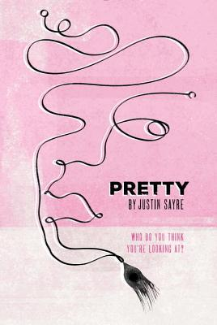 | Pretty  by Justin Sayre  Y/Fic/Sayre  Confident, stylish, and easygoing at school, Sophie is struggling in her home life. Stepping in to help as her mother's addiction spirals out of control, Sophie's aunt teaches the biracial Sophie new lessons about her heritage. While helping to heal the wounds inflicted by alcoholism, Sophie's renewed sense of self challenges her perception of place in the affluent, "liberal" neighborhood of Park Slope where she lives.
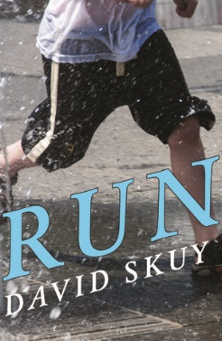 | Run  SP  by David Skuy  Y/Fic/Skuy  Overweight and bullied, Lionel tries to attract as little attention as possible. Then he discovers something about himself: he's a fast runner. He joins the running group and is recruited for the school track team. But being on the track team and getting more attention brings Lionel closer to the bullies he's been avoiding and makes him a target.
Kit Meets Covington (Ride #1)
AN

by Bobbi J.G. Weiss
Y/Fic/Weiss

Trying to move on from her mother's death and afraid of riding after a bad fall, Kit Bridges doesn't quite know what to expect when her father takes a position at The Covington Academy, a prestigious boarding school in England. Things are looking up when Kit meets her cool, possibly secretly royal new roommate, Anya, and the boys of Covington, like Will, with their charming accents. But she hadn't anticipated such a strict headmistress as Lady Covington. Or the expectation that every student be a rider. Or the wild horse that she seems to have a strange and special bond with.

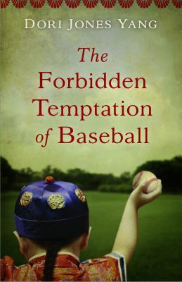 | The Forbidden Temptation of Baseball  HF  by Dori Jones Yang  Y/Fic/Yang  Despite his impulsive and curious nature, twelve-year-old Leon is determined to follow the Emperor's rules--to live with an American family, study hard, and return home to modernize China. But he also must keep the braid that shows his loyalty—and resist such forbidden American temptations as baseball. As Leon overcomes teasing and makes friends, his elder brother becomes increasingly alienated and disturbed. Eventually, Leon faces a tough decision, torn between his loyalty to his birth country—and his growing love for his new home.

Read, loved, and recommended by your teen librarian, Sara.
Check them out at the public library today!

25 Boston Rd
Chelmsford, MA 01824
sdempster@chelmsfordlibrary.org
978-256-5521 x 133

