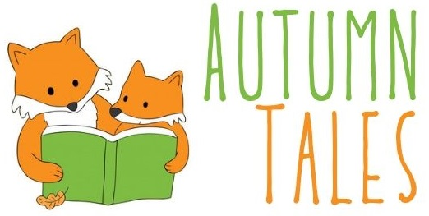

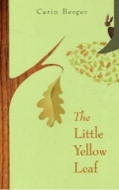 | The Little Yellow Leaf  By Carin Berger  call number:  JJ/Berger
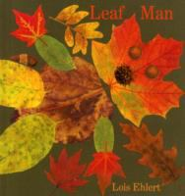 | Leaf Man  by Lois Ehlert  call number:  JJ/Ehlert
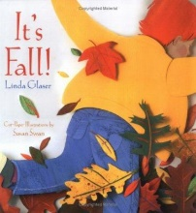 | It’s Fall!  By Linda Glaser  call number:  JJ/Glaser
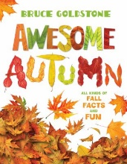 | Awesome Autumn  by Bruce Goldstone  call number:  JJ/Goldstone
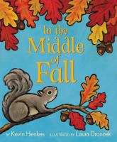 | In the Middle of Fall  by Kevin Henkes  call number:  JJ/Henkes
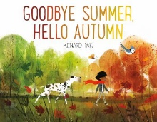 | Goodbye Summer, Hello Autumn  By Kenard Pak  call number:  JJ/Pak
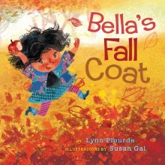 | Bella’s Fall Coat  by Lynn Plourde  call number:  JJ/Plourde
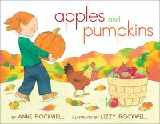 | Apples and Pumpkins  by Anne Rockwell  call number:  JJ/Rockwell
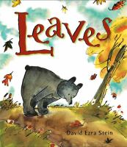 | Leaves  By David Ezra Stein  call number:  JJ/Stein
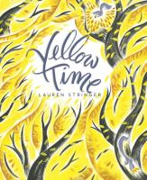 | Yellow Time  by Lauren Stringer  call number:  JJ/Stringer
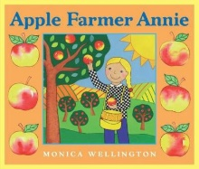 | Apple Farmer Annie  by Monica Wellington  call number:  JJ/Wellington
In the Nonfiction Section, look for these call numbers:
J/508.2 (seasons)
J/582.16 (leaves)
J/634.11 (apples)
J/635.62 (pumpkins)

