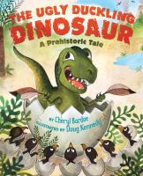 | The Ugly Dinosaur  by Cheryl Bardoe  call number:  JJ/Bardoe
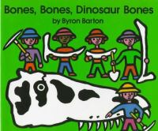 | Bones, Bones, Dinosaur Bones  by Byron Barton  call number:  JJ/Barton
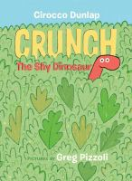 | Crunch, the Shy Dinosaur  By Cirocco Dunlap  call number:  JJ/Dunlap
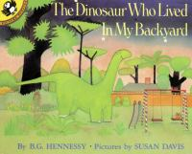 | The Dinosaur Who Lived in My Backyard  by B. G. Hennessy  call number:  JJ/Hennessy
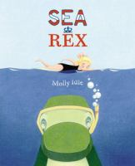 | Sea Rex  By Molly Idle  call number:  JJ/Idle

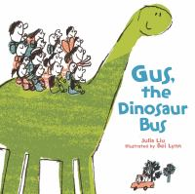 | Gus, the Dinosaur Bus  By Siyuan Liu  call number:  JJ/Liu
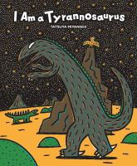 | I Am a Tyrannosaurus  By Tatsuya Miyanishi  call number:  JJ/Miyanishi
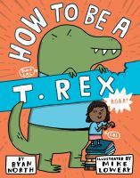 | How to Be a T. Rex  by Ryan North  call number:  JJ/North
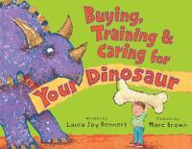 | Buying, Training, and Caring for Your Dinosaur  By Laura Rennert  call number:  JJ/Rennert
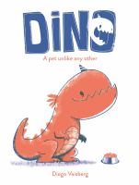 | Dino  by Diego Vaisberg  call number:  JJ/Vaisberg
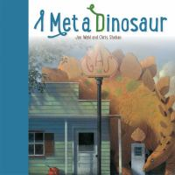 | I Met a Dinosaur  by Jan Wahl  call number:  JJ/Wahl

Want to learn facts about dinosaurs?
Look for call number J/567.9
in the nonfiction section.

