The best
Princess Stories
you’ve never heard of

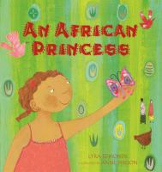 |  |  | An African Princess  by Lyra Edmonds  call number:  JJ/Edmonds
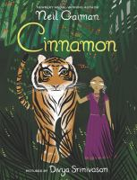 |  |  | Cinnamon  by Neil Gaiman  call number:  JJ/Gaiman
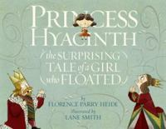 |  |  | Princess Hyacinth  by Florence Parry Heide  call number:  JJ/Heide
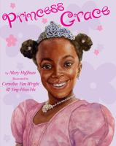 |  |  | Princess Grace  by Mary Hoffman  call number:  JJ/Hoffman
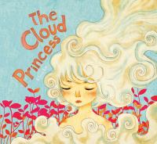 |  |  | The Cloud Princess  by Khoa Lê  call number:  JJ/Le
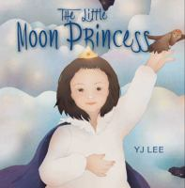 | The Little Moon Princess  by Y.J. Lee  call number:  JJ/Lee
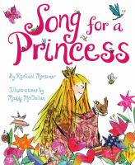 | Song for a Princess  by Rachael Mortimer  call number:  JJ/Mortimer
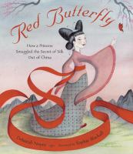 | Red Butterfly  by Deborah Noyes  call number:  JJ/Noyes
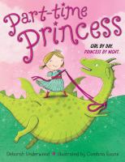 |  | Part-Time Princess  by Deborah Underwood  call number:  JJ/Underwood
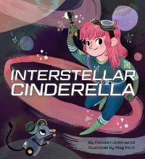 |  | Interstellar Cinderella  by Deborah Underwood  call number:  JJ/Underwood
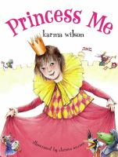 |  | Princess Me  by Karma Wilson  call number:  JJ/Wilson

Want more suggestions? Ask a librarian!

