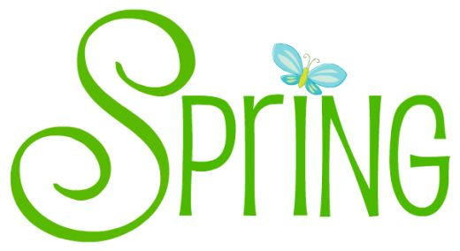
Stories

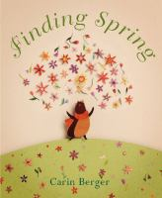 | Finding Spring  by Carin Berger  call number:  JJ/Berger
Shake a Leg, Egg!
By Kurt Cyrus

call number:
JJ/Cyrus

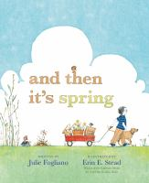 | And Then It’s Spring  by Julie Fogliano  call number:  JJ/Fogliano
Spring Is Here
By Tarō Gomi

call number:
JJ/Gomi

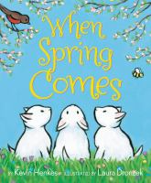 | When Spring Comes  by Kevin Henkes  call number:  JJ/Henkes
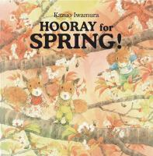 | Hooray for Spring!  By Kazuo Iwamura  call number:  JJ/Iwamura
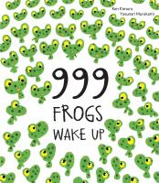 | 999 Frogs Wake Up  by Ken Kimura  call number:  JJ/Kimura
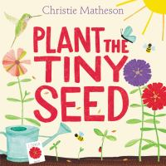 | Plant the Tiny Seed  by Christie Matheson  call number:  JJ/Matheson
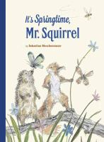 | It’s Springtime, Mr. Squirrel!  by Sebastian Meschenmoser  call number:  JJ/Meschenmoser
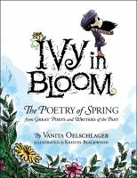 | Ivy Bloom  By Vanita Oelschlager  call number:  J/Poetry/Oelschlager
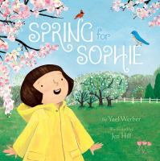 | Spring for Sophie  by Yael Werber  call number:  JJ/Werber
In the Nonfiction Section:
Look for call number J/508.2

