A Perfect Day
By Carin Berger

call number:
JJ/Berger

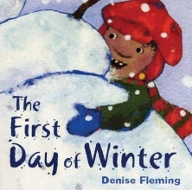 | The First Day of Winter  By Denise Fleming  call number:  JJ/Fleming
Oh!
By Kevin Henkes

call number:
JJ/Henkes

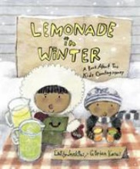 | Lemonade in Winter  by Emily Jenkins  call number:  JJ/Jenkins
Immi’s Gift
by Karin Littlewood

call number:
JJ/Littlewood

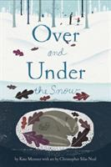 | Over and Under the Snow  by Kate Messner  call number:  JJ/Messner
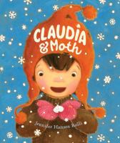 | Claudia and Moth  By Jennifer Hansen Rolli  call number:  JJ/Rolli
Little Penguins
by Cynthia Rylant

call number:
JJ/Rylant

Snow
by Uri Shulevitz

call number:
JJ/Shulevitz
Before Morning
by Joyce Sidman

call number:
JJ/Sidman
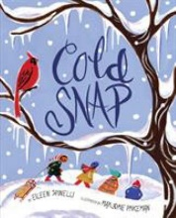 | Cold Snap  by Eileen Spinelli  call number:  JJ/Spinelli
In the Nonfiction Section, look for these call numbers:
J/508.2 (seasons)
J/551.5784 (snow)
J/796.9 (winter sports)

