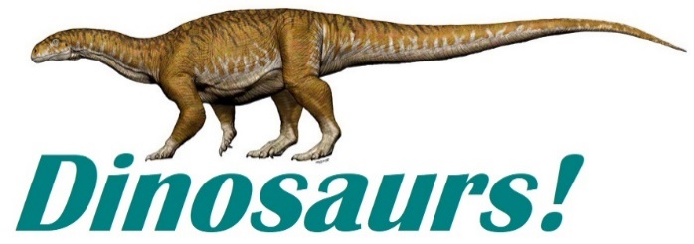

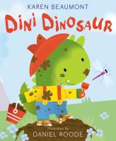 | Dini Dinosaur  by Karen Beaumont  call number:  JJ/Beaumont
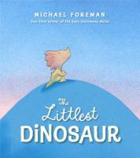 | The Littlest Dinosaur  by Michael Foreman  call number:  JJ/Foreman
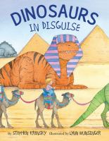 | Dinosaurs in Disguise  By Stephen Krensky  call number:  JJ/Krensky
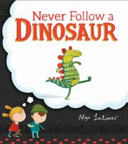 | Never Follow a Dinosaur  By Alex Latimer  call number:  JJ/Latimer
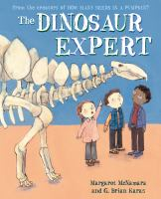 | The Dinosaur Expert  by Margaret McNamara  call number:  JJ/McNamara

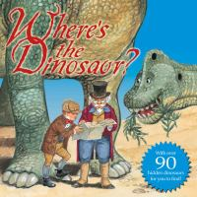 | Where’s the Dinosaur?  by Keith Moseley  call number:  JJ/Moseley
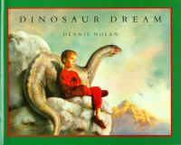 | Dinosaur Dream  By Dennis Nolan  call number:  JJ/Nolan
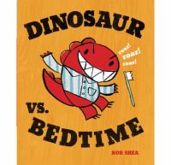 | Dinosaur Versus… series  by Bob Shea  call number:  JJ/Shea
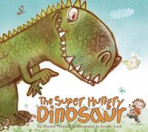 | The Super Hungry Dinosaur  By Martin Waddell  call number:  JJ/Waddell
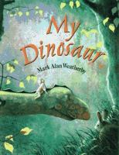 | My Dinosaur  by Mark Alan Weatherby  call number:  JJ/Weatherby
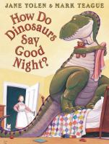 | How Do Dinosaurs… series  by Jane Yolen  call number:  JJ/Yolen

Want to learn facts about dinosaurs?
Look for call number J/567.9 in the nonfiction section.

