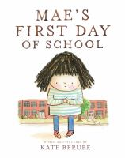 | Mae’s First Day of School  by Kate Berube  call number:  JJ/Berube
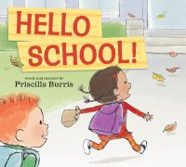 | Hello School!  by Patricia Burris  call number:  JJ/Burris
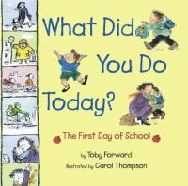 | What Did You Do Today?  by Toby Forward  call number:  JJ/Forward
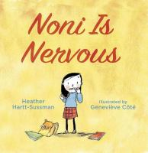 | Noni Is Nervous  by Heather Hartt-Sussman  call number:  JJ/Hartt-Sussman
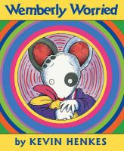 | Wemberly Worried  by Kevin Henkes  call number:  JJ/Henkes
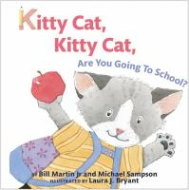 | Kitty Cat, Kitty Cat, Are You Going to School?  by Bill Martin, Jr.  call number:  JJ/Martin
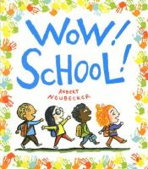 | Wow! School!  by Robert Neubecker  call number:  JJ/Neubecker
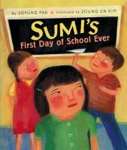 | Sumi’s First Day of School Ever  by Soyoung Pak  call number:  JJ/Pak
School’s First Day of School
by Adam Rex

call number:
JJ/Rex

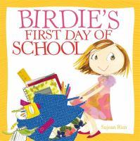 | Birdie’s First Day of School  by Sujean Rim  call number:  JJ/Rim
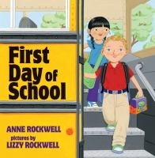 | First Day of School  by Anne Rockwell  call number:  JJ/Rockwell

